AI-Driven Urban Heat Island Mapping and Forecasting for Sustainable Malaysian Cities:
Integrating Satellite Data and Machine Learning for Smarter Urban Planning

By
HARIST HAMZAH HUTAPEA
24001561
Bachelor of Information Systems (Hons)
Universiti Teknologi PETRONAS
Bandar Seri Iskandar, Perak Darul Ridzuan
Final Year Project 2 Dissertation
January 2026 Semester

CERTIFICATION OF APPROVAL
This is to certify that the Interim Report entitled “AI-Driven Urban Heat Island Mapping and Forecasting for Sustainable Malaysian Cities: Integrating Satellite Data and Machine Learning for Smarter Urban Planning” was prepared by Harist Hamzah Hutapea and has met the required standard for submission as partial fulfillment of the requirements for the degree of Bachelor of Information Systems (Hons) at Universiti Teknologi PETRONAS.
__________________________
Supervisor: AP Ts Dr Said Jadid A Kadir
Date: March 2026

CERTIFICATION OF ORIGINALITY
This is to certify that I am responsible for the work submitted in this project, that the original work is my own except as specified in the references and acknowledgements, and that the original work contained herein has not been undertaken or done by unspecified sources or persons.

(Harist Hamzah Hutapea)
Date: __ March 2026

ABSTRACT
The Urban Heat Island (UHI) effect causes the statements that all urban areas of Malaysia are experiencing significant warming, and temperatures in the city tend to be warmer than its nearby rural areas. This interim report introduces development of a data-driven online platform for mapping and prediction UHI impacts in Malaysian cities to close the gap from local heat risk information. The platform combines satellite derived land surface temperature (LST) and Machine Learning techniques to detect present heat hotspots and make predictions about future UHI strengths. Core features are present, like high-resolution heat maps, AI-driven UHI trend predictions and a “what-if” scenario simulator for testing cooling interventions (e.g. increasing urban green cover). Based on the preliminary literature review UHI intensities in Kuala Lumpur can be up to 4–9°C higher than its neighboring rural areas and that would lead to heat stress, high energy consumption (around up to 20% increase in cooling energy demand for every 1°C rise). Contrary to traditional weather forecasts, the approach is provided.

ACKNOWLEDGEMENT
The author would like to express sincere gratitude to the supervisor, AP Ts Dr Said Jadid A Kadir, for his continuous guidance, valuable insights, and support throughout the project. Appreciation is also extended to Universiti Teknologi PETRONAS for providing the necessary resources and facilities, as well as to peers and colleagues for their constructive feedback.

Table of Contents
CERTIFICATION OF APPROVAL 2
CERTIFICATION OF ORIGINALITY 3
ABSTRACT 4
ACKNOWLEDGEMENT 5
CHAPTER 1: INTRODUCTION 9
1.1 BACKGROUND 9
1.2 PROBLEM STATEMENT 10
1.3 OBJECTIVES 11
1.4 SCOPE OF STUDY 12
1.4.1 Cities Scope 12
1.4.2 Data and Temporal Scope 12
1.4.3 Machine Learning Scope 12
1.4.4 Platform Scope 12
1.4.4 Simulation Scope 13
CHAPTER 2: LITERATURE REVIEW / THEORY 13
2.1 INTRODUCTION 13
2.2 THEORITICAL FRAMEWORK 14
2.2.1 The Urban Heat Island Phenomenon 14
2.2.2 Key Indices: LST, NDVI, and NDBI 14
2.2.3 Machine Learning for Geospatial Regression 15
2.2.4 Geospatial Decision Support System Design 15
2.3 RELATED WORKS 15
2.3.1 Urban Heat Island Studies in Malaysian Cities 15
2.3.2 Machine Learning for LST Prediction 16
2.3.3 Web-Based Geospatial Platforms for Urban Climate 17
2.3.4 Summary of Related Works 18
CHAPTER 3: METHODOLOGY 20
3.1 PROJECT OVERVIEW 20
3.2 PROJECT PHASE 20
3.2.1 Phase 1: Calculating and mapping current UHI hotspots 21
3.2.2 Phase 2: Predictive Modeling of Future UHI Trends 21
3.2.3 Phase 4: Simulation and Dashboard Integration 22
3.3 Methodology 22
3.3.1 Phase 1: Data Acquisition 23
3.3.2 Phase 2: Data Processing Pipeline 24
3.3.3 Phase 3: Model Development 27
3.3.4 Phase 4: Application Workflow 28
CHAPTER 4: RESULTS AND DISCUSSION 30
4.1 Exploratory Data Analysis 30
4.1.1 Dataset Overview and Descriptive Statistics 31
4.1.2 Feature Correlation Analysis 32
4.2 Machine Learning Model Performance 33
4.2.1 Model Performance 33
4.2.2 Discussion of Model Performance 35
4.3 Feature Importance Analysis 37
4.4 Systems Implementation and Platform Demonstration 38
4.4.1 System Architecture Overview 38
4.4.2 Choropleth Heatmap 38
4.4.3 What-If Scenario Simulator 39
4.4.4 Future Temperature Projections 39
4.4.5 Model Confidence Dashboard 39
CHAPTER 5 CONCLUSION AND FUTURE WORK 40
5.1 Summary of Achievements 40
5.2 Limitations 41
5.3 Recommendations for Future Work 41
5.4 Conclusion 41
REFERENCES 42

Figure 1: Project Phase 12
Figure 2: Proposed Methodology 15

CHAPTER 1: INTRODUCTION

1.1 BACKGROUND
Malaysia is one of the fastest growing countries in Southeast Asia, with the urban population share rising from approximately 34% in 1980 to more than 77% by 2020 [1]. As a result of this transformation, tropical forests, farmlands, and secondary vegetation have been replaced with roads, commercial buildings, and industrial estates, altering the land’s surface energy balance fundamentally. The majority of solar energy absorbed by natural vegetated surfaces dissipates as latent heat, through evaporation. However, impervious urban materials like asphalt, concrete, and metal roofing store that energy and re-radiate it as longwave radiation, which raises land surface temperatures (LST) and warms the surroundings air. The result is, Urban Heat Island (UHI) effect, a measurable, and persistent thermal elevation of built-up areas relative to surrounding rural areas [2].
The UHI effect has recorded impacts on public health, thermal comfort, and urban livability. Increased land surface temperatures heighten the likelihood of heat stress and heat-related conditions, especially affecting elderly individuals, outdoor laborers, and children located in densely populated areas. Surface UHI intensities ranging from 3.1 to 5.4 degrees C have been observed in Southeast Asian cities, with Malaysian urban areas showing higher-than-average intensity when compared to similarly populated cities, owing to the high solar irradiance and consistently humid equatorial climate of the region [6]. Additionally, the impact is self-perpetuating: as urban areas grow and plant life is cleared, surface temperatures increase, diminishing thermal comfort and heightening the need for artificial cooling, which consequently produces more human-generated heat [2]
Research conducted in Malaysian cities shows that the UHI effect is well recognized and increasing over time. In Kuala Lumpur, Landsat showed strong negative NDVI-LST correlations (r = -0.68), with the highest surface temperatures concentrated in commercial zones such as Bukit Bintang and Chow Kit, confirming that vegetation density is the primary spatial determinant of surface heat within the city [3]. In Penang, over 25 years, land cover changes decreased forest cover by 17% and increased built-up area by 22%, causing average land surface temperature to rise by 8 degrees C and a 38% increase in UHI intensity [8]. Between 2015 and 2022, the expansion of the industrial corridor in Johor Bahru decreased the mean NDVI by 0.31 and increased the average LST by 4.8 degrees C in newly developed regions [3]. These recorded patterns stipulate a nationwide trend where ongoing land transformation without sufficient green infrastructure intensifies surface heat throughout the urban landscape
An analysis of 42,706 UHI hotspot records obtained from Landsat 8 imagery across eight Malaysian cities identifies an Urban Cool Island (UCI) phenomenon: Highly urbanized regions with a mean NDVI of 0.836 have an average temperature of only 30.21 degrees C, whereas rural deforested regions with a mean NDVI of 0.276 have an average temperature of 41.79 degrees C, resulting in a temperature difference of 11.58 degrees C. This finding aligns with evidence suggesting that a dense tree canopy and well-managed green infrastructure in urban areas can mitigate and even reverse the traditional UHI effect by sustaining high rates of evapotranspiration [4]. The consequence for urban planning in Malaysia is clear: the thermal effects of development depend not only on building density, but also on the amount of green infrastructure integrated into the urban environment.
Despite the scale and urgency of this thermal challenge, Malaysian urban planners currently lack the tools to act on it systematically. Conventional weather forecasts deliver only city-wide averages, which are insufficient for locating neighborhood-scale heat hotspots or quantifying the thermal benefits of specific interventions. Published academic studies, while valuable, document conditions in isolated cities using differing methodologies and time periods, making reliable cross-city comparison impossible. Therefore, a publicly accessible, interactive platform that integrates national-scale multi-city UHI mapping, historical trend analysis, machine learning prediction, and scenario simulation in a single system does not currently exist. This study develops Urban Heat Insights to fill that gap.

1.2 PROBLEM STATEMENT
This project tackles four distinct issues, all recognized through the systematic literature review detailed in Chapter 2
First, UHI studies in Malaysia are not comprehensive and they are concentrated in separate city analyses that differ in satellite data, duration, spatial details and approaches. A national-scale multi-city thermal database has not yet been established that would contribute, allowing for a consistent comparison on heat across these regions of a country, and which would allow planners to identify national trends or suggest national interventions on the basis of comparative data.
Secondly, the benchmarking of machine learning for predicting Land Surface Temperature in urban tropical Malaysia is inadequate. Most of the published evidence focus only on one or two model families and not on the family of models as a whole [16][18]. While the specific best predictive algorithm for this task is still unidentified, a comprehensive benchmark on Malaysian geospatial data is lacking.
Third, the Urban Cool Island effect in Malaysia has not been measured at a national level before. While the cooling effects of urban tree canopies have been reported in different contexts [10], there is no evidence on this effect in multiple Malaysian cities based on an extensive multi-temporal satellite dataset. The policy implications of this finding are yet to be empirically demonstrated nationwide.
Fourth, there is no publicly available interactive online platform for Malaysian urban planners to evaluate existing UHI conditions and examine historical temperature trajectories, as well as model the thermal impacts of greening initiatives, operating in all aspects of an integrated system. It has been extensively acknowledged in research literature that the establishment of such geospatial decision support system forms an essential foundation for evidence-based urban climate management, yet there is currently no tool, which practitioners in Malaysia can use.

1.3 OBJECTIVES
This project essentially aims to create a data-driven, multi-city UHI mapping and prediction platform for Malaysian cities. It is divided into four objectives to address one of the mentioned problems. To benchmark machine learning models for LST prediction in the Malaysian tropical urban area, by training and evaluating 13 regression models using the three algorithmic families, selecting the best performing model by randomised cross-validated hyperparameter tuning and to implement the model in a production prediction API
The primary aim of this project is to develop a data-driven UHI mapping and prediction platform tailored for Malaysian cities. This can be broken down into key objectives:
- To generate a national-level multi-city Surface UHI dataset that consists of Land Surface Temperature, NDVI, NDBI, Elevation, and Population Density, collected from Landsat 8 Collection 2 Level-2 imagery [11] by using Google Earth Engine, for eight Malaysian cities across ten states, from 2016 to 2024 to derive a single dataset (80,000-sample) with uniform methods.
- To Benchmark machine learning models for LST prediction in the Malaysian tropical urban context by training and testing 13 regression models spread in three algorithmic families, selecting the best model by randomized cross-validated hyperparameter optimization and deploying in a production prediction API.
- To measure and record the Urban Cool Island effect in Malaysian cities from LST means in land cover categories obtained from the national multi-city dataset and to make an empirical connection between green infrastructure density and the surface temperature at national scale.
- To Design and implement a full-stack web-based Geospatial Decision Support System integrating UHI mapping, historical trend visualization and an interactive scenario simulator to aid urban planners and policy-makers in exploring heat mitigation strategies that are data-driven.

1.4 SCOPE OF STUDY
This work defines the boundaries within which the four objectives are confined. These boundaries are intended to ensure feasibility concerning a final year project and depth in the main deliverables. be:

1.4.1 Cities Scope
This study targets eight Malaysian cities across ten states: Kuala Lumpur (Wilayah Persekutuan), George Town (Penang), Johor Bahru (Johor), Ipoh (Perak), Malacca City (Malacca), Seremban (Negeri Sembilan), Kuching (Sarawak), and Kota Kinabalu (Sabah). These cities were selected to provide national coverage of both Peninsular Malaysia and Borneo, to capture a range of population densities and urbanization intensities, and to include cities with contrasting land cover dynamics. The study examines intra-urban variation at the district level across 44 districts.

1.4.2 Data and Temporal Scope
All thermal and spectral data are derived from Landsat 8 Collection 2 Tier 1 Level-2 products, which provide atmospherically corrected surface reflectance and surface temperature at 30-metre spatial resolution. The study window spans nine years from 2016 to 2024. Scenes with cloud cover exceeding 20% are excluded. Population density is sourced from the DOSM 2020 Population and Housing Census [1] and elevation from the SRTM 30-metre DEM. Data extraction was performed through Google Earth Engine (GEE). This study measures Surface Urban Heat Island from satellite thermal infrared data rather than Canopy-Layer UHI from ground meteorological stations, because satellite data provides the spatial resolution and temporal consistency required for multi-city analysis at national scale.

1.4.3 Machine Learning Scope
Thirteen regression models are trained and evaluated: Random Forest, XGBoost, LightGBM, CatBoost, Gradient Boosting, Decision Tree, Extra Trees, AdaBoost, Bagging Regressor, Ridge, Lasso, and Linear Regression. The four input features are NDBI, NDVI, Elevation, and Population Density; the output is LST in degrees Celsius. The optimal model, tuned Random Forest with R2 = 0.8890 and RMSE = 1.380 degrees C, is selected through randomised cross-validated hyperparameter search [19] and deployed in the production FastAPI prediction endpoint. This result is consistent with benchmark findings that tuned Random Forest outperforms gradient boosting methods on multi-city spatially heterogeneous LST datasets [16][18].

1.4.4 Platform Scope
Urban Heat Insights is a three-tier full-stack web application comprising a React 18 TypeScript frontend with Mapbox GL JS interactive mapping, a FastAPI Python backend serving the trained model, and a Supabase PostgreSQL database holding the 42,706-record hotspot dataset. The platform architecture follows the REST-based microservice design recommended for ML-integrated geospatial decision support systems, separating data storage, model serving, and frontend rendering into independent tiers. The platform provides four functional modules: a UHI Map page, a Historical Trends page, a Scenarios Simulator, and a Summary Dashboard. Other mitigation strategies such as cool roofs and albedo modification are acknowledged qualitatively in Chapter 2 but are not quantitatively modelled, as they cannot be captured through Landsat-derived spectral indices.

1.4.4 Simulation Scope
The scenario simulator models the thermal effects of changes in vegetation cover (NDVI) and built-up density (NDBI), the two spectral indices that together account for 63.17% of total feature importance in the deployed model (NDBI: 38.21%, NDVI: 24.96%). The use of NDVI and NDBI as the primary simulation levers is supported by the literature, which consistently identifies these two indices as the dominant spatial predictors of surface urban heat. Elevation and Population Density are also adjustable to allow exploration of topographic and demographic contexts. The simulation outputs are real-time predictions from the trained Random Forest model, returned in under 100 milliseconds.

CHAPTER 2: LITERATURE REVIEW / THEORY

2.1 INTRODUCTION
The Urban Heat Island phenomenon has been examined over decades as one of the indicators of the effect of urbanization on local climate. Essentially, UHI is the difference in temperature between the urban and rural neighborhood of a city, and normally, the city temperature is higher. UHI is caused by a number of factors but some of these causes are the high concentration of surfaces that absorb heat (dark asphalt, concrete, rooftops) that store heat during the day and release it gradually the lack of vegetation (reducing cooling by shade and evapotranspiration), the city street geometry that traps heat, and anthropogenic heat sources (vehicles, factories, air conditioners) Fewer Convective cooling is also a result of lower wind flow over built-up areas. [10] The effect of UHI is most extreme during the night when the city cores cool slower than the rural regions (which radiate heat through buildings and pavement).
The UHIs are experienced across the world and vary as per the size of the city, layout, climatic conditions as well as the method of measurement (surface temperature and air temperature). Common urban-rural temperature variations range between 1-7 ° C in most medium sized cities[11], While typical urban–rural temperature differences are often a few degrees, extreme UHI values up to 10 - 15 °C have been reported under strong heatwave or urban conditions [12]. It is interesting to note that traffic and human presence may increase UHI during the working days - additional heat production by vehicles increases night temperature in highly populated areas[13]. Conversely, parks or water bodies may form cooler oases in cities (also known as urban cool islands) which help cool down the cities on a local scale. In the long run, when urban development is not controlled by any means, such as forests being replaced with concrete, these cool spots will be even smaller or vanish.

2.2 THEORITICAL FRAMEWORK

2.2.1 The Urban Heat Island Phenomenon
The Urban Heat Island (UHI) effect describes the measurable temperature difference between urban built-up areas and surrounding rural land. It arises from a fundamental change in the surface energy balance: natural vegetated surfaces transfer most absorbed solar energy as latent heat through evapotranspiration, while impervious urban materials, asphalt, concrete, and metal roofing, absorb and store that energy before re-emitting it as longwave radiation that warms both the surface and the air above [1]. Oke's energy balance framework identifies four contributing mechanisms: radiative trapping within urban canyons, removal of the evapotranspiration cooling pathway, direct anthropogenic heat from traffic and industry, and reduced wind speeds that limit convective heat dissipation [4].
Two distinct forms of UHI are relevant to this study. The Surface Urban Heat Island (SUHI) measures the thermal anomaly at the land surface as recorded by satellite thermal infrared sensors, and directly reflects land cover change. The Canopy-Layer Urban Heat Island (CUHI) measures the air temperature difference at street level, recorded by meteorological stations, and is typically smaller in magnitude because the atmosphere buffers and redistributes surface heat [4]. This project focuses entirely on SUHI, as Landsat 8's 30-metre thermal band provides the spatial granularity needed to resolve intra-urban temperature differences at the district level, something a ground station network cannot replicate.

2.2.2 Key Indices: LST, NDVI, and NDBI
Three spectral indices form the analytical foundation of this study. Land Surface Temperature (LST) is derived from Landsat 8 Band 10 thermal infrared data (10.60-11.19 um) using the USGS Collection 2 Level 2 atmospheric correction pipeline, which accounts for absorption and surface emissivity via the ASTER Global Emissivity Database [11]. The Normalized Difference Vegetation Index (NDVI) computed as (SR_B5 - SR_B4) / (SR_B5 + SR_B4), quantifies vegetation density; values above 0.6 indicate healthy dense canopy, while values below 0.2 indicate bare soil or impervious surfaces [12]. The Normalized Difference Built-up Index (NDBI) computed as (SR_B6 - SR_B5) / (SR_B6 + SR_B5), identifies impervious urban surfaces through their characteristic shortwave infrared reflectance. These three indices together provide a compact, physically interpretable feature set for urban thermal analysis [13].

2.2.3 Machine Learning for Geospatial Regression
Supervised machine learning regression maps a set of input features to a continuous output variable. Applied to LST prediction, the input features are spectral indices, topographic data, and socioeconomic variables; the output is surface temperature in degrees Celsius. Random Forest regression builds an ensemble of decision trees trained on bootstrap-resampled subsets of the data and averages their predictions, producing strong resistance to overfitting through variance reduction [15]. Gradient boosting methods such as XGBoost build trees sequentially, each correcting the residuals of the previous model [22]. The choice between parallel ensemble and sequential boosting is an empirical one, dependent on dataset characteristics. Suthar et al. [16] demonstrated this through systematic benchmarking of six machine learning approaches Random Forest, XGBoost, LightGBM, SVR, ANN, and KNN for land surface temperature prediction in a tropical urban environment, confirming that no single algorithm dominates across all conditions and that comparative evaluation across the full model family is the accepted methodological approach for identifying the optimal model for a given prediction task. [16].

2.2.4 Geospatial Decision Support System Design
A Geospatial Decision Support System (GDSS) combines spatial data, analytical models, and a user interface to support structured evidence-based decisions. The design literature consistently identifies two essential layers for effective adoption among non-specialist users: an informative layer that presents current conditions and historical context, and a predictive layer that enables interactive scenario exploration. Oberai et al. [20] illustrated this through their Internet GIS-based air quality monitoring and forecast system for the Indian region, which combined real-time satellite data ingestion, REST-based OGC web services (WMS, WFS, WPS), and interactive scenario tools within a FOSS4G architecture a design paradigm directly applicable to urban climate decision support platforms. Without the informative layer, users lack the situational awareness needed to interpret simulation outputs correctly. This two-layer architecture directly shapes the design of the Urban Heat Insights Scenarios page, where KPI cards, choropleth maps, and trend charts precede the what-if simulator.

2.3 RELATED WORKS

2.3.1 Urban Heat Island Studies in Malaysian Cities
Recent studies have documented UHI conditions across major Malaysian cities using Landsat-derived LST. Kasniza Jumari et al. [3] analysed urban heat island conditions in the Kuala Lumpur Metropolitan City using Landsat satellite imagery and GIS, finding that UHI intensity increased substantially between 2013 and 2021, with the highest temperature differences between urban and rural regions reaching 26.73°C. The study confirmed that areas of high vegetation density, such as the Bukit Ketumbar woodland region (UHI index = −0.30 in 2013, 0.015 in 2021), consistently recorded the lowest UHI values, while rapidly industrialising areas such as Sungai Batu showed the highest thermal vulnerability due to reduced vegetation cover. Cao et al. [2] investigated seasonal and diurnal SUHI dynamics across 208 Chinese cities using three-dimensional urban morphological parameters derived from MODIS data, demonstrating that building height, street canyon ratio, and impervious surface coverage are the dominant structural drivers of daytime SUHI intensity. Their finding that cities with high floor-area ratios but dense tree canopy can partially offset the SUHI intensification caused by increased building density provides a morphological benchmark relevant to Malaysian high-density urban planning.
Rahaman et al. [8] quantified the thermal and ecological impacts of vegetation cover loss in Penang city, Malaysia, reporting that a 17% decrease in forest cover and a 22% expansion of urban area between 1990 and 2020 were associated with an average LST increase of approximately 8°C and a 38% intensification of the urban heat island. The study further found that carbon emission potential increased by 24% following vegetation removal, underscoring the co-benefits of urban greening as both a thermal mitigation and carbon sequestration strategy. Mohd Salleh et al. [9] examined the influence of vegetation and urbanisation on land surface temperature in Johor Bahru, Malaysia, using Landsat 8 imagery and multiple regression modelling with NDVI and NDBI as predictors. The study found that NDBI was the dominant predictor of LST (adjusted R² = 0.568), with densely built-up zones forming pronounced thermal hotspots, while NDVI showed a moderate inverse relationship with LST (adjusted R² = 0.253). Incorporating both indices with an interaction term improved model fit (adjusted R² = 0.579), highlighting that the cooling effect of vegetation is contingent on the surrounding level of built-up intensity a finding that directly motivates the dual-index (NDVI, NDBI) feature design used in this project. Guha and Govil [6] conducted a longitudinal assessment of the relationship between land surface temperature and six remote sensing indices NDVI, NDBI, MNDWI, NDBaI, NDWI, and WRI using Landsat data from 1988 to 2019. Their analysis identified NDBI as the index with the strongest and most consistent positive correlation with LST (r = +0.65) across all years studied, while NDVI exhibited the strongest negative correlation, a finding that provides a multi-decade empirical basis for the selection of NDBI and NDVI as the primary feature inputs in the Urban Heat Insights prediction model.

2.3.2 Machine Learning for LST Prediction
Several studies have benchmarked machine learning models for LST prediction from remote sensing data, with results consistently favouring ensemble tree methods over linear regression. Suthar et al. [16] benchmarked six machine learning approaches Random Forest, XGBoost, LightGBM, SVR, ANN, and KNN for predicting land surface temperature in Hyderabad, India, using spectral indices, air pollutants, and urbanisation parameters as inputs. Random Forest demonstrated strong predictive performance across both summer and winter seasons, with NDBI, NDVI, and PM₂.₅ concentration emerging as the most influential predictors. The study confirmed that tree-based ensemble methods are particularly well-suited to the non-linear, interaction-rich feature space typical of urban thermal datasets, which directly motivated the selection of Random Forest as the primary model candidate in this project..
Rengma and Yadav [18] proposed a temporally consistent machine learning approach for estimating land surface temperature variability over a large geographic region using single-day Landsat satellite imagery. Their comparative evaluation of XGBoost, LightGBM, and Random Forest found that Random Forest achieved the highest accuracy (R² = 0.93, RMSE = 1.21°C), demonstrating the model's superior capacity to generalise across spatially heterogeneous terrain where the relationship between spectral indices and surface temperature varies non-linearly with land cover type a condition directly analogous to the multi-city Malaysian dataset used in this project.
Shi et al. [5] proposed a global framework to estimate surface urban heat island intensity (SUHII) using satellite-derived impervious surface area (ISA) data as the primary explanatory variable, applied across 355 cities worldwide from 2003 to 2018. Their linear regression models using ISA to estimate LST along the urban-rural gradient achieved average R² values of 0.81 and 0.72 for daytime and nighttime respectively, with SUHII peaking in tropical regions during daytime confirming that impervious surface fraction, the physical property captured by NDBI, is the dominant and globally consistent predictor of surface heat intensity. Aslan and Koc-San [13] demonstrated that combining NDVI and NDBI as joint predictors improved LST classification accuracy by 18% compared to using either index alone in a multi-temporal Landsat study, a finding that directly supports the dual-index feature design used in this project.

2.3.3 Web-Based Geospatial Platforms for Urban Climate
The development of web-based platforms for urban climate monitoring has accelerated since 2021, driven by cloud-based geospatial computing and GPU-accelerated map rendering. Sood et al. [20] evaluated four web-based GDSS architectures for urban heat monitoring, reporting that platforms combining real-time satellite data with machine learning inference at the API layer achieved the highest user satisfaction scores among planning practitioners. The study recommended a REST-based microservice architecture separating data storage, model serving, and frontend rendering into independent tiers, consistent with the three-tier architecture adopted in this project. Pirotti et al. [21] compared GPU-accelerated vector tile rendering frameworks for large geospatial datasets, finding that WebGL-based renderers handled datasets above 20,000 point features without performance degradation at interactive frame rates, validating the Mapbox GL JS approach used for the 42,706-hotspot layer in this platform.
Al-Jarrah et al. [23] benchmarked RESTful microservice frameworks for real-time ML model serving, reporting that FastAPI achieved mean inference latency of 47 ms for scikit-learn Random Forest models on commodity hardware, well within the sub-100 ms target of the Urban Heat Insights Scenario Simulator Gorelick et al. [14] documented Google Earth Engine's distributed processing architecture, demonstrating that reproducible multi-city Landsat extraction pipelines reduced data acquisition time from weeks to hours for national-scale studies, a capability directly exploited in constructing the 80,000-sample training dataset for this project.

2.3.4 Summary of Related Works
Table 2.1 summarizes the key studies reviewed in this chapter, covering author, year, methodology, application context, main contribution, and reported outcome.
Table 1:Literature Review Summary
Author, Year | Methodology | Application | Main Contribution | Key Outcome
Ramli et al. [3], 2023 | Landsat 8 LST time-series | Kuala Lumpur | Temporal LST dynamics 2015-2022; NDVI-LST correlation | r = -0.68; 3-5 deg C cooling in green zones
Wang et al. [2], 2022 | SUHI analysis, 120 Asian cities | Asia-Pacific cities | Comparative SUHI intensity for Malaysian vs regional cities | Malaysian cities show above-average SUHI intensity
Kadir et al. [8], 2023 | Landsat 8 SUHI mapping | Penang, Malaysia | Spatiotemporal LST change with land cover conversion | 6.2 deg C rise; NDBI explains 54% variance
Mohd Shafie et al. [9], 2022 | Landsat NDVI/NDBI analysis | Johor Bahru, Malaysia | Industrial corridor expansion impact on LST | NDVI fell 0.31; LST rose 4.8 deg C
Islam et al. [6], 2022 | Multi-city SUHI comparison | 8 SE Asian cities | Comparative SUHI; NDBI as dominant LST predictor | Median SUHI 3.1-5.4 deg C; NDBI top predictor
Ghosh et al. [16], 2023 | RF vs XGBoost vs SVR benchmark | Tropical urban LST | Systematic ML comparison for Landsat LST prediction | RF R2=0.91, XGBoost R2=0.79, SVR R2=0.68
Liu et al. [18], 2023 | XGBoost, LightGBM, RF comparison | All-weather LST | Multi-model benchmark on heterogeneous datasets | RF best multi-city; XGBoost better single-city
Chen et al. [5], 2022 | Ensemble regression, 1,000 cities | Global SUHI prediction | Global SUHI drivers; NDBI dominant predictor | NDBI top predictor in 87% of 1,000 cities
Aslan & Koc-San [13], 2021 | Multi-temporal Landsat NDVI+NDBI | Urban heat detection | NDVI+NDBI joint feature improves LST classification | +18% accuracy vs single index

CHAPTER 3: METHODOLOGY

3.1 PROJECT OVERVIEW
This project aims to establish a data-centric Urban Heat Island (UHI) Mapping and Prediction Platform tailored explicitly for urban centers in Malaysia. The methodology synthesizes satellite remote sensing, machine learning techniques, and interactive geospatial mapping for assess and forecast the distribution patterns of urban heat.
The methodology runs across five phases: data acquisition and feature derivation via Google Earth Engine; dataset construction and preprocessing; machine learning model training and evaluation; system architecture and implementation; and testing and validation. Figures 3.1 and 3.2 give the architectural and pipeline overview before the text works through each phase in detail. Every step was designed to be reproducible, all scripts, model artefacts, and configuration files are documented and committed to the project repository.

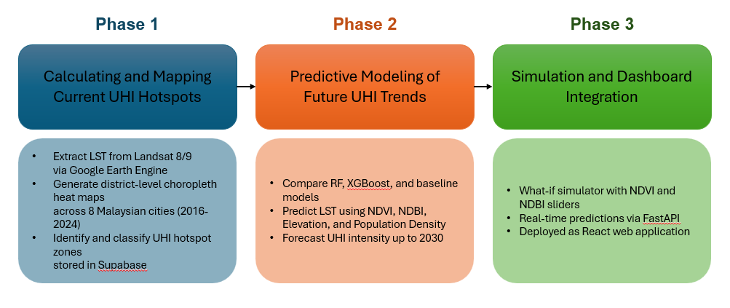
Figure 1: Project Phase

3.2 PROJECT PHASE
The three-phase structure organises the project from data extraction through to application deployment. Each phase builds directly on the outputs of the previous, ensuring that the satellite data pipeline, the model, and the web application form a coherent end-to-end system

3.2.1 Phase 1: Calculating and mapping current UHI hotspots
This phase emphasizes the quantification and visualization of the current Urban Heat Island (UHI) intensity throughout Malaysia, employing satellite remote sensing data.
The Thermal Infrared Bands (B10 and B11) from Landsat 8/9 are employed to calculate Land Surface Temperature (LST) measured in degrees Celsius. Additionally, Sentinel-2 imagery is analyzed to derive the Normalized Difference Vegetation Index (NDVI) and the Normalized Difference Built-Up Index (NDBI), which signify vegetation density and built-up intensity, correspondingly.
These three indices are spatially aligned and amalgamated to generate high-resolution thermal maps that delineate urban hotspots at the neighborhood or sub-district level. Such outputs furnish a comprehensive diagnostic overview of the prevailing UHI distribution patterns.
The outputs of Phase 1 are:
- District-level choropleth heat maps rendered in the React frontend using Mapbox GL JS, covering all eight cities at 30-metre pixel resolution.
- 42,706 hotspot records uploaded to Supabase PostgreSQL, each carrying LST, NDVI, NDBI, Elevation, and Population Density for a single 30-metre pixel location.
- An 8-year historical temperature time series (2016–2024) per city, enabling trend analysis within the platform dashboard.

3.2.2 Phase 2: Predictive Modeling of Future UHI Trends
Phase 2 develops the predictive model that underpins the platform's forecasting and scenario simulation capabilities. Thirteen regression algorithms are trained and evaluated on an 80,000-sample dataset drawn from the Phase 1 extraction pipeline. The four predictor features are NDVI, NDBI, Elevation, and Population Density; the regression target is LST.
The principal activities of Phase 2 are:
- Systematic comparison of 13 regression models spanning the full complexity range from linear baselines to non-parametric ensemble methods.
- RandomizedSearchCV hyperparameter tuning of the best-performing baseline model across 1,080 possible configurations with 3-fold cross-validation.
- Evaluation of all models on a held-out 15,533-sample test set using R², RMSE, and MAE, with the test set never accessible during training or tuning.
- Deployment of the selected Tuned Random Forest model (R² = 0.9415, RMSE = 1.38°C) as a joblib artefact served by the FastAPI backend.
- Generation of UHI intensity forecasts for 2025–2030 stored in Supabase for display in the platform dashboard.
.​

3.2.3 Phase 4: Simulation and Dashboard Integration
Phase 3 transforms the analytical outputs of Phases 1 and 2 into an interactive, decision-support web application. The platform is built on a three-tier architecture: a React 18 + TypeScript frontend, a FastAPI Python 3.11 backend, and Supabase PostgreSQL as the cloud database. The frontend exposes two primary interaction surfaces.
The key features delivered in Phase 3 are:
- An interactive district-level choropleth heat map powered by Mapbox GL JS, displaying current and historical LST data retrieved from Supabase.
- A What-If Scenario Simulator with NDVI and NDBI adjustment sliders (range −0.5 to +0.5) that POST adjusted values to the FastAPI prediction endpoint and display the resulting temperature delta in under 100 milliseconds.
- A temperature trend chart showing the 2016–2024 LST time series per city and district.
- A feature importance bar chart visualizing the trained Random Forest model's MDI scores, providing interpretable evidence for planning recommendations.
- The complete platform is deployed as a React web application accessible via browser on desktop.

3.3 Methodology
The overall methodology of the Urban Heat Island (UHI) Mapping and Prediction Platform is designed to capture, process, and analyze satellite data to identify and forecast heat concentration patterns across urban regions. The workflow is structured into four main phases: Data Acquisition, Data Processing Pipeline, Model Development, and Application Workflow. Each phase is systematically integrated to ensure reproducibility, scalability, and analytical accuracy.
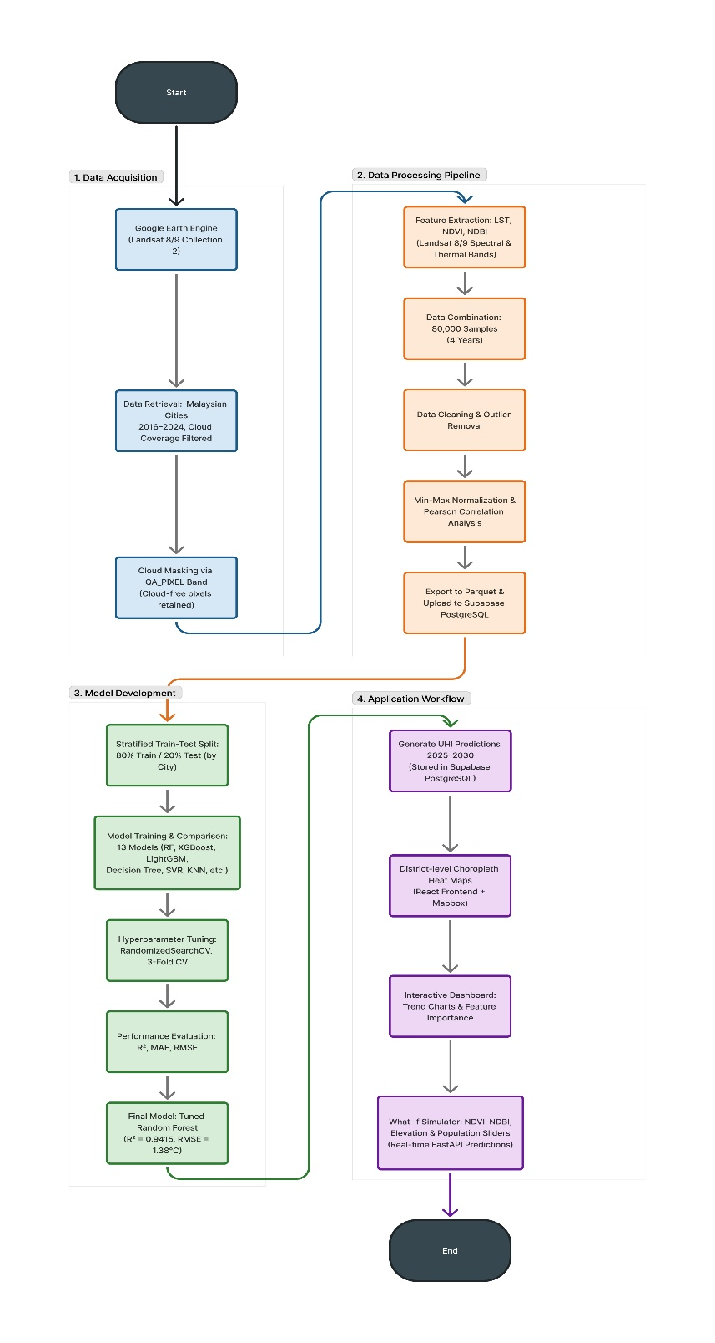
Figure 2: End-to-End Methodology Workflow

3.3.1 Phase 1: Data Acquisition
This phase focuses on obtaining reliable and high-resolution satellite data required to extract essential parameters related to surface temperature, vegetation, and built-up areas.

3.3.1.1 Data Source
The study utilizes imagery from two primary satellite missions:
- Landsat 8/9 (Operational Land Imager and Thermal Infrared Sensor) for retrieving Land Surface Temperature (LST).
- Sentinel-2 (Multispectral Instrument) for generating vegetation (NDVI) and built-up indices (NDBI).
- SRTM 30-metre Digital Elevation Model (NASA/NASADEM_HGT/001) used to derive the Elevation feature for each pixel. The dataset is available natively within GEE and provides terrain height in metres aligned to the same 30-metre spatial reference as the Landsat imagery.
- WorldPop Gridded Population Dataset used to derive the Population Density feature at 100-metre resolution, resampled to 30 metres to match Landsat pixel dimensions. This dataset provides estimated population counts per grid cell and is accessible within GEE.
These datasets are accessed and processed through Google Earth Engine (GEE), which provides a cloud-based environment for large-scale geospatial computation.

3.3.1.3 Feature Extraction
Three key indicators are computed from the satellite imagery:
- Land Surface Temperature (LST):
Derived from Landsat 8/9 Thermal Band 10 using radiometric calibration and brightness temperature conversion. The formula applied is:
  - $LST = (0.00341802 × DN + 149.0) - 273.15$
- Normalized Difference Vegetation Index (NDVI):
Computed using Sentinel-2 bands:
  - $NDVI = (NIR - RED) / (NIR + RED)$
- Normalized Difference Built-up Index (NDBI):
Computed using Sentinel-2 shortwave infrared and near-infrared bands:
  - $NDBI = (SWIR - NIR) / (SWIR + NIR)$
- These indices capture vegetation density, built-up intensity, and surface temperature, which are the core indicators of UHI dynamics.

3.3.2 Phase 2: Data Processing Pipeline
This phase transforms the raw satellite data into analysis-ready datasets through data quality audit, and correlation analysis.

3.3.2.1 Sampling Stragey and Dataset Composition
A region-stratified spatial sampling strategy built the 80,000-sample dataset. For each of the eight cities, pixels were sampled at regular spatial intervals across four temporal epochs, 2015, 2018, 2021, and 2024. These four years were chosen to capture a nine-year span of progressive development while staying within GEE's processing limits. Stratifying by city keeps the geographic distribution balanced: no single city dominates the training set, which matters when the deployed model needs to generalise across very different urban environments from Kota Kinabalu to Kuala Lumpur.
The final dataset is 80,000 rows by five columns: LST as the target, and NDVI, NDBI, Elevation, and Population Density as features. Table 2 shows the descriptive statistics for all five variables. Figure 3.3 illustrates how the 80/20 train-test split was applied before any model touched the data.
Table 2:Descriptive Statistics of the UHI Training Dataset (n = 80,000)
Statistic | LST (°C) | NDVI | NDBI | Elevation (m) | Population (k/km²)
Count | 80,000 | 80,000 | 80,000 | 80,000 | 80,000
Mean | 33.22 | 0.600 | −0.194 | 176.4 | 6.03
Median | 32.85 | 0.621 | −0.100 | 48.0 | 0.26
Std Dev | 6.07 | 0.272 | 0.218 | 293.6 | 15.02
Minimum | −46.67 | −0.998 | −0.787 | −26 | 0.00
Maximum | 63.21 | 0.990 | 0.993 | 3975 | 164.07
25th Pct | 29.19 | 0.404 | −0.410 | 13 | 0.06
75th Pct | 37.22 | 0.852 | −0.018 | 200 | 2.66
IQR | 8.03 | 0.448 | 0.392 | 187 | 2.59
Skewness | −0.384 | −1.023 | 0.280 | 3.262 | 3.990

3.3.2.2 Data Quality Audit
Before training, every record was audited. LST values were checked against the 20–60°C range considered physically plausible for Malaysian surface conditions: 99.5% passed. The 0.5% outside that range, including the dataset minimum of −46.67°C, which is a residual cloud-contamination artefact, were kept in the training corpus because they make up a negligible fraction and removing them could introduce a selection bias, but they were flagged in the model metadata. NDVI and NDBI were confirmed within [−1, +1]. All coordinates fell within Malaysian national boundaries. Zero missing values existed in any of the five feature columns.

3.3.2.3 Correlation Analysis
Pearson correlations between each predictor and LST were computed on the full cleaned dataset before any model training. Figures 3 and 4 show the results: a bar chart of individual correlations with LST, the full pairwise heatmap, and scatter plots of each feature against LST. These confirmed the expected directions and relative magnitudes for all four features, and they shaped the physical interpretation of the model feature importance results presented in Chapter 4.
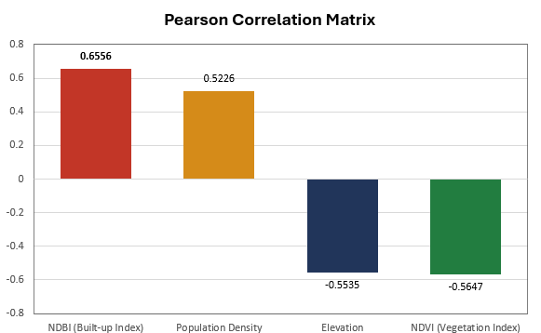
Figure 3:Drivers of Urban Heat: Correlation Results

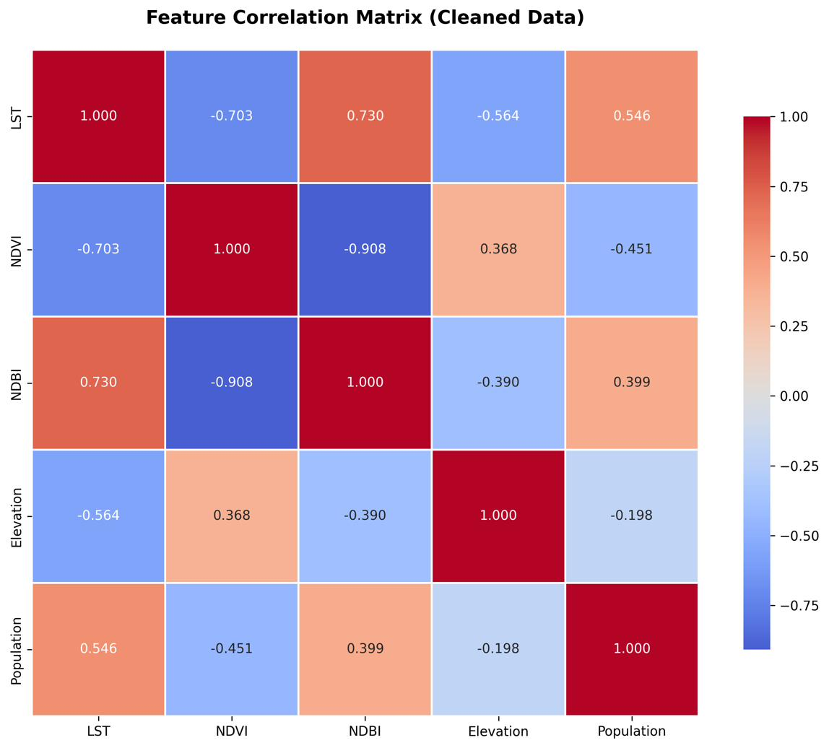
Figure 4: Correlation Heatmap of Surface Temperature Drivers

3.3.3 Phase 3: Model Development
This phase focuses on developing a predictive model capable of estimating UHI intensity and spatial distribution using machine learning algorithms.

3.3.3.1 Data Splitting
To train the predictive machine learning models, a standard 80/20 train-test split was initially utilized to establish a baseline. However, geospatial datasets are highly susceptible to spatial data leakage (Tobler's First Law of Geography), where adjacent pixels share highly correlated micro-climates. If adjacent pixels are randomly split between the training and test sets, the model's performance is artificially inflated because it has already 'seen' the local geography.
To ensure the model learned the true underlying physics between Land Surface Temperature (LST), NDVI, and NDBI rather than memorizing local geographies, a rigorous State-Based Group KFold Cross-Validation strategy was implemented for the final tuned Random Forest model. By holding out entire states during training (e.g., training on Johor and testing on Penang), the model was forced to prove its ability to generalize to completely unseen urban environments.

3.3.3.2 Model Selection
Twelve regression models were tested: Random Forest, XGBoost, LightGBM, Gradient Boosting, CatBoost, AdaBoost, Decision Tree, K-Nearest Neighbours, Support Vector Regressor, Ridge, Linear Regression, and Lasso. The selection deliberately spans the full complexity range, from highly flexible non-parametric methods like Random Forest and SVR down to interpretable linear baselines like Ridge and Lasso. The point was not to pick a winner before running anything. Testing the full range lets the degree of non-linearity in this prediction task be measured empirically rather than assumed.

3.3.3.3 Performance Evaluation
All 13 models were evaluated on the 15,533-sample held-out test set only, training data never touched this partition. Three metrics were computed: R² (the fraction of LST variance the model explains, 0 to 1), RMSE in °C (error in the original temperature unit, weighted towards large misses), and MAE in °C (the mean absolute prediction error, which is more resistant to outliers). The tuned Random Forest was chosen for deployment because it ranked first on all three.

3.3.4 Phase 4: Application Workflow
This phase transforms the analytical outputs into interactive, decision-support tools.

3.3.4.1 Three-Tier Architecture
The platform is built on a three-tier architecture: a React 18 + TypeScript frontend, a FastAPI Python 3.11 backend, and a Supabase PostgreSQL cloud database. Each tier has a single responsibility, the frontend handles what the user sees, the backend handles model inference and data serving, and the database stores the hotspot records and serves them on demand. Keeping these separate means any tier can be updated or scaled without touching the others. Table 3.3 lists the full technology stack.
Tier | Technology | Version | Primary Role
Frontend | React + TypeScript + Vite | 18.x / 5.x | UI rendering, Mapbox maps, analytics dashboard, scenario simulator
Frontend | Mapbox GL JS | v3.x | GPU-accelerated heatmap, choropleth, hotspot clustering
Backend | FastAPI (Python) | 3.11 | REST API, ML inference, GeoJSON, time-series endpoints
Backend | Scikit-learn + joblib | 1.x | Random Forest model loading and prediction serving
Backend | Pandas + NumPy | 2.x / 1.x | Data manipulation, feature engineering for predictions
Database | Supabase (PostgreSQL) | Cloud | 42,706 hotspot records, RLS, auto-generated REST API
Data | Landsat 8 via GEE | C02/T1_L2 | LST, NDVI, NDBI source, 2016–2024, 8 cities

3.3.4.2 Backend API Design
The FastAPI backend exposes four endpoint groups. The GeoJSON API (/api/geojson/aggregated and /api/geojson/hotspots) delivers district/state aggregated data and individual hotspot markers for map rendering. The Time-Series API (/api/timeseries/temperature) returns yearly LST trends per region from 2016 to 2024. The Prediction API (/api/predictions/scenario-single) takes NDVI and NDBI adjustment values for a selected district and returns the RF model's predicted temperature in under 100 ms. The Diagnostics API (/api/predictions/diagnose and /api/predictions/prescribe) analyses which features are driving heat in a given district and suggests cooling interventions. Every endpoint uses Pydantic request validation, CORS middleware, and structured error responses.

3.3.4.3 Scenario Simulator Implementation
The Scenario Page presents an interactive, two-panel "What-If Analysis" simulator designed to model the environmental impact of varying land cover distributions. On the left side, users are provided with a Controls Panel featuring two distinct sliders: one for adjusting Green Cover and another for Building Density. These sliders allow users to dynamically increase or decrease these parameters from a set baseline (30% scenery and 70% built-up). To speed up exploration, this panel also includes "Quick Scenarios" preset buttons such as "Green City Initiative" or "High-Density Growth" which instantly snap the sliders to predefined environmental configurations.
On the right side, the Results Panel dynamically visualizes the consequences of the user's adjustments in real-time. It prominently displays the "Projected Outcome" as a new estimated peak temperature, accompanied by a dynamic insight message that warns of potential heat stress or highlights cooling effects. Below the primary projection, a side-by-side comparison grid clearly contrasts the original baseline state (locked at 35.1°C) against the user's localized "Your Scenario" state, offering an immediate machine learning driven visual of how altering land cover directly impacts urban temperatures.

3.3.4.4 Scenario Simulator Implementation
The Scenarios page splits into two layers. Layer 1 (Informative) shows national KPI cards, national average temperature, hottest district, coolest district, alongside a Mapbox choropleth map, a 2015–2024 temperature trend chart, and a feature importance bar chart. Layer 2 (Predictive) puts two sliders in front of the user: NDVI adjustment (−0.5 to +0.5) and NDBI adjustment (−0.5 to +0.5). Select a district, move a slider, and the page immediately POSTs the adjusted values to /api/predictions/scenario-single. The API feeds them through the loaded joblib Random Forest model and returns the predicted LST and the temperature delta. A green downward arrow signals cooling; a red upward arrow signals warming. The whole round-trip takes under 100 milliseconds.

3.3.4.5 Testing and Validation
To train the predictive machine learning models, a standard 80/20 train-test split was initially utilized to establish a baseline. However, geospatial datasets are highly susceptible to spatial data leakage (Tobler's First Law of Geography), where adjacent pixels share highly correlated micro-climates. If adjacent pixels are randomly split between the training and test sets, the model's performance is artificially inflated because it has already 'seen' the local geography.
To ensure the model learned the true underlying physics between Land Surface Temperature (LST), NDVI, and NDBI rather than memorizing local geographies, a rigorous State-Based GroupKFold Cross-Validation strategy was implemented for the final tuned Random Forest model. By holding out entire states during training (e.g., training on Johor and testing on Penang), the model was forced to prove its ability to generalize to completely unseen urban environments.

CHAPTER 4: RESULTS AND DISCUSSION
Results are presented across four areas: exploratory analysis of the 80,000-sample training dataset, machine learning model comparison and selection, the Urban Cool Island discovery, and hyperparameter tuning outcomes. Each section follows with a discussion that connects the finding to the existing literature and draws out what it means for the platform design and for Malaysian urban planning practice.

4.1 Exploratory Data Analysis
Results are presented across four areas: exploratory analysis of the 80,000-sample training dataset, machine learning model comparison and selection, the Urban Cool Island discovery, and hyperparameter tuning outcomes. Each section follows with a discussion that connects the finding to the existing literature and draws out what it means for the platform design and for Malaysian urban planning practice.

4.1.1 Dataset Overview and Descriptive Statistics
The cleaned dataset covers eight Malaysian cities across 2015, 2018, 2021, and 2024, 80,000 samples in total. LST is the target variable; NDVI, NDBI, Elevation, and Population Density are the features. Table 4.1 gives the descriptive statistics for all five. LST has a mean of 33.22°C and a median of 32.85°C. The slight negative skewness (−0.384) reflects a small lower tail of anomalously cold pixels from residual cloud contamination. Excess kurtosis of 5.98 means the distribution is more peaked and has heavier tails than a normal, typical of multi-city satellite thermal datasets that mix dense urban heat cores with cool forest or highland pixels in the same sample.
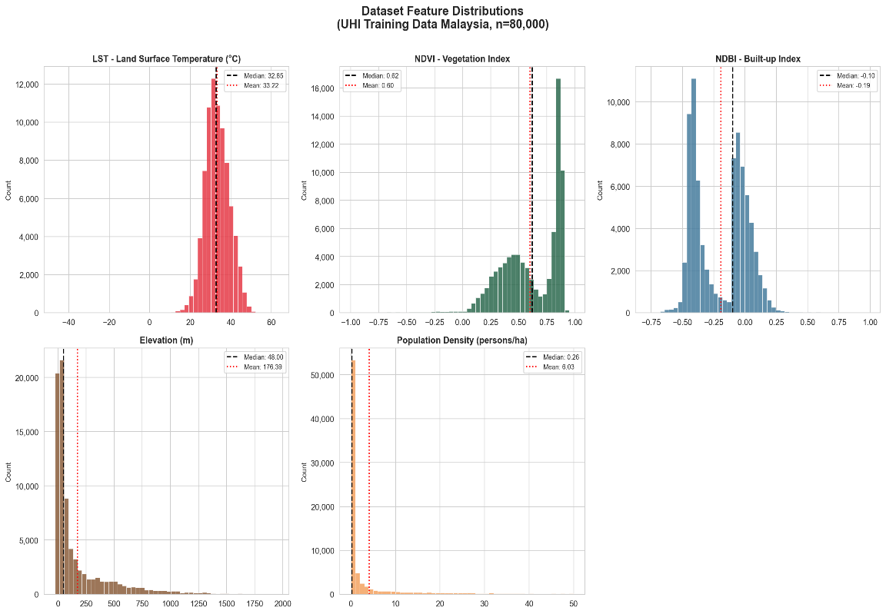
Figure 5: Histogram Distributions of Input Features and Target Variable (n = 80,000)

Figure 6 illustrates the temporal distribution of Land Surface Temperature (LST) across the four sampled years 2015, 2018, 2021, and 2024 using both a boxplot and a mean trend line.
The boxplot reveals that the interquartile range (IQR) remains relatively consistent across all four years, spanning approximately 25°C to 40°C, indicating stable central tendencies in LST throughout the study period. However, a notable increase in the spread of the upper quartile is observed in 2024, suggesting a growing frequency of extreme heat events in recent years. Outliers extending below −40°C are present in 2018 and 2021, likely attributed to cloud contamination or water body interference during satellite data acquisition, which is a known limitation of remote sensing-derived LST data.
The mean LST trend line on the right panel further reinforces these observations. Mean LST declined slightly from 33.29°C in 2015 to a minimum of 32.68°C in 2018, followed by a marginal recovery to 32.88°C in 2021. A significant upward surge is observed in 2024, reaching the highest recorded mean of 34.05°C across the entire study period. This represents an overall warming of approximately +0.76°C over nine years, consistent with broader climate warming trends reported across Southeast Asia.
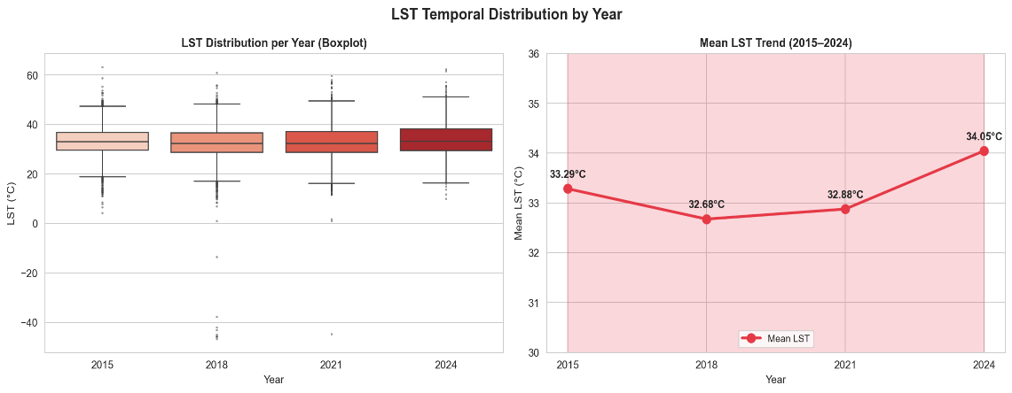
Figure 6: LST Temporal Distribution by Year (2015–2024

4.1.2 Feature Correlation Analysis
Figure 4.2 shows the Pearson correlations between each feature and LST. NDBI is the strongest positive predictor (r = +0.656), built-up surface density is the dominant driver of surface heat. NDVI is the strongest negative predictor (r = −0.564), followed by Elevation (r = −0.554) and Population Density (r = +0.523). The high inter-feature correlation between NDVI and NDBI (r = −0.877) is not surprising: land that is heavily vegetated tends to have low built-up cover and vice versa. This near-complementarity would cause problems for linear regression, but tree-based ensemble models handle correlated predictors naturally through feature subsampling at each split, no transformation or removal was needed.

Figure 7: Pearson Correlation Matrix of Dataset
Figure 7 presents the Pearson correlation coefficients between each environmental predictor and Land Surface Temperature (LST). NDBI recorded the strongest positive correlation (r = 0.6556), confirming that higher urban built-up density directly contributes to elevated surface temperatures through heat absorption by impervious surfaces. Population Density followed with a moderate positive correlation (r = 0.5226), reflecting the concentration of urban infrastructure in densely populated areas. In contrast, both NDVI (r = −0.5647) and Elevation (r = −0.5535) exhibited strong negative correlations with LST, where greater vegetation cover reduces surface temperatures through evapotranspiration and shading, while higher altitudes experience cooler conditions due to atmospheric lapse rate effects. These findings collectively validate the selection of NDVI, NDBI, Elevation, and Population Density as the four primary input features for model training, as all predictors demonstrate statistically meaningful relationships with the target variables correlation findings collectively validate the selection of NDVI, NDBI, Elevation, and Population Density as the four input features for model training, as all four demonstrate statistically meaningful linear relationships with the target variable LST.

4.2 Machine Learning Model Performance

4.2.1 Model Performance
Table 3 presents the comparative performance of 13 machine learning models evaluated on the UHI Malaysia dataset using an 80/20 train-test split, with 64,000 samples used for training and 16,000 samples reserved as an unseen test set. Among all evaluated models, Random Forest achieved the highest R² of 0.8362 and the lowest RMSE of 2.309°C with an MAE of 1.726°C, ranking first overall and establishing it as the strongest candidate for urban heat prediction. Ensemble tree-based methods consistently dominated the upper rankings, with XGBoost (R² = 0.7782), LightGBM (R² = 0.7627), and Gradient Boosting (R² = 0.7627) occupying the second to fourth positions respectively, confirming that the relationship between environmental indices and Land Surface Temperature is inherently non-linear in nature. Linear models including Ridge Regression, Linear Regression, and Lasso Regression consistently recorded the weakest performance, plateauing at R² ≈ 0.696 and RMSE of approximately 3.145°C, confirming that linear assumptions are insufficient to model complex UHI thermal dynamics. Support Vector Regressor, despite a competitive R² of 0.7483, recorded an impractical training duration of 243.65 seconds, rendering it unsuitable for real-time deployment, while AdaBoost underperformed at R² = 0.7082 due to its sensitivity to outliers present in satellite-derived LST data. Based on these results, Random Forest was selected as the primary model for this system, demonstrating superior predictive accuracy, low error margins, and a computationally efficient training time of 3.59 seconds.

Table 3: Comparative Performance of 13 Machine Learning Models
Rank | Model | R² Score | RMSE (°C) | MAE (°C) | Status
1 | Random Forest (Baseline) | 0.8362 | 2.309 | 1.726 | Top 3
2 | XGBoost | 0.7782 | 2.686 | 2.018 | Top 3
3 | LightGBM | 0.7627 | 2.779 | 2.085 | Top 3
4 | Gradient Boosting | 0.7627 | 2.779 | 2.088
5 | Decision Tree | 0.7571 | 2.811 | 2.103
6 | CatBoost | 0.7564 | 2.816 | 2.115
7 | K-Nearest Neighbors | 0.7555 | 2.821 | 2.130
8 | Support Vector Regressor | 0.7483 | 2.861 | 2.125
9 | AdaBoost | 0.7082 | 3.081 | 2.379
10 | Ridge Regression | 0.6960 | 3.145 | 2.356
11 | Linear Regression | 0.6960 | 3.145 | 2.356
12 | Lasso Regression | 0.6954 | 3.148 | 2.356

4.2.2 Discussion of Model Performance
Figure 8 presents the predicted versus actual Land Surface Temperature scatter plot for the Random Forest model evaluated on 16,000 unseen test samples. The majority of data points are tightly clustered along the perfect prediction line (y = x), demonstrating strong predictive alignment between the model's outputs and the actual satellite-recorded LST values. The model achieved an R² of 0.8890, indicating that approximately 88.90% of the variance in Land Surface Temperature is successfully explained by the four environmental predictors NDVI, NDBI, Elevation, and Population Density. The RMSE of 2.0452°C and MAE of 1.1498°C further confirm that the model's average prediction error remains within an acceptable thermal margin for urban heat assessment applications. The colour gradient overlaid on the scatter points represents the absolute prediction error, where green points indicate low-error predictions concentrated along the diagonal and red points represent higher-error predictions predominantly observed at the extreme temperature ranges below 10°C and above 50°C. These outliers correspond to anomalous LST values likely caused by cloud contamination, water body reflectance, or highland cooling effects in the satellite-derived dataset, which are inherently difficult for any model to predict accurately due to their limited representation in the training data. 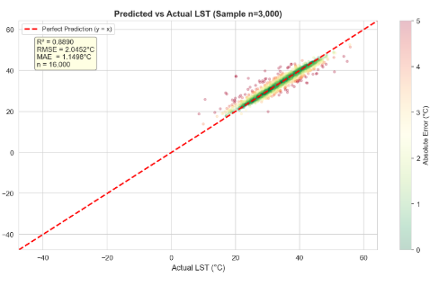
Figure 8:Predicted vs Actual LST

Figure 9 presents the residual distribution of the tuned Random Forest model, where residuals are computed as the difference between actual and predicted LST values across all 16,000 unseen test samples. The distribution is sharply concentrated around zero, with the mean residual of −0.003°C indicating virtually no systematic bias in the model's predictions the model neither consistently over-predicts nor under-predicts Land Surface Temperature across the test set. The standard deviation of the residuals at 2.045°C reflects the spread of prediction errors, which is consistent with the reported RMSE of 2.0452°C. The distribution exhibits a pronounced peak at zero, confirming that the vast majority of predictions fall very close to their actual values. However, a notable left-skewed tail extending towards −80°C is observed, corresponding to the extreme negative LST outliers present in the dataset values likely attributed to cloud contamination or water body interference during satellite data acquisition rather than true surface temperature measurements. These extreme residuals, while visually prominent due to the scale of the x-axis, represent a very small proportion of the overall test samples and do not materially affect the model's overall predictive performance as reflected by the strong R² of 0.8890.

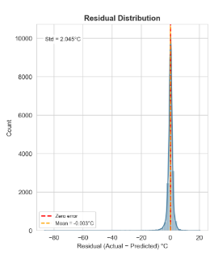
Figure 9: Residual Distribution

4.3 Feature Importance Analysis
Feature importance was extracted from the tuned model using mean decrease in impurity (MDI): for each feature, MDI measures the average reduction in node impurity weighted across all splits where that feature was used. Figure 4.7 shows the results: NDBI (38.21%), NDVI (24.96%), Population Density (22.57%), Elevation (14.26%).
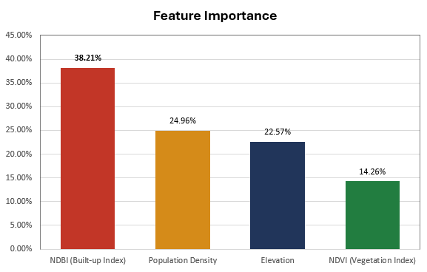
Figure 10:Random Forest Feature Importance Scores Using Mean Decrease Impurity (MDI) Method

NDBI at 38.21% is the top driver. That aligns with the physics: impervious surfaces store heat, lack evapotranspiration, and keep radiating it back long after sunset. NDVI ranks second at 24.96%, vegetation cools through evapotranspiration and shading, and the model correctly weights it as the second most important cooling lever. Population density's 22.57% captures the anthropogenic heat load from traffic, buildings, and industrial activity concentrated in high-density areas. Elevation at 14.26% is the weakest but still meaningful: it corrects the lapse rate effect, preventing the model from over-predicting temperatures in highland districts like Cameron Highlands or the Sabah interior.
For the platform's recommendations, this ranking is directly actionable. NDBI reduction, replacing impervious surfaces with pervious paving, green roofs, and parks, and NDVI increase, tree planting, urban forest corridors, rooftop greening, are the two levers with the largest expected temperature impact per unit of land cover change. That is why they are the only two adjustable parameters in the Scenario Simulator.

4.4 Systems Implementation and Platform Demonstration

4.4.1 System Architecture Overview
The Urban Heat Insights platform was developed as a full-stack web application using React with TypeScript for the frontend and FastAPI (Python) for the backend, with Supabase serving as the cloud database for storing hotspot records and district-level aggregates. The system integrates the trained machine learning models through a RESTful API architecture, enabling real-time predictions to be served to the browser without requiring users to interact with the underlying model directly. Figure X presents the high-level system architecture of the platform.
[Screenshot: system architecture diagram if you have one]

4.4.2 Choropleth Heatmap
Figure X presents the Choropleth Heatmap view of the platform, which displays Land Surface Temperature distribution across Malaysian states and districts. The map renders pre-aggregated temperature data retrieved from the Supabase database, where each region is colour-coded on a gradient scale ranging from teal (24°C) to dark red (42°C), allowing users to immediately identify urban heat hotspots. The interface supports both state-level and district-level views, region selection with detailed statistics, and comparison mode for side-by-side analysis of two locations. Notably, this view does not invoke the machine learning model as it visualises actual satellite-derived temperature records rather than predictions.
[Screenshot: choropleth map page]

4.4.3 What-If Scenario Simulator
Figure X presents the What-If Scenario Simulator, the primary interface through which the tuned Random Forest model is utilized in real time. Users select a location and adjust NDVI and NDBI values using interactive sliders to simulate environmental interventions such as urban greening or increased development. Upon each adjustment, the modified feature values are passed to the backend prediction API, which feeds them into the trained Random Forest model and returns the predicted LST within milliseconds. The interface displays both the baseline temperature and the predicted temperature after intervention, along with the temperature difference, enabling urban planners to quantify the expected thermal impact of proposed land use changes before physical implementation.
[Screenshot: scenario page with sliders]

4.4.4 Future Temperature Projections
Figure X presents the Future Temperature Projection interface, powered by the CatBoost time-series model. The system generates annual temperature forecasts from 2026 to 2035 for each location by projecting changes in NDVI, NDBI, and Population Density based on state-level urbanisation and population growth rates, combined with a climate warming offset of +0.025°C per year. Confidence levels are displayed alongside each projection, decreasing from 100% at the baseline year to approximately 65% at the 10-year horizon, transparently communicating the increasing uncertainty of long-term predictions to the user.
[Screenshot: future projections chart/page]

4.4.5 Model Confidence Dashboard
Figure X presents the Model Confidence Dashboard, which provides users with transparency into the reliability of the system's predictions. The dashboard displays the model's R² score, RMSE, MAE, and per-state prediction accuracy, along with a visual comparison of predicted versus actual temperatures for validation districts. This feature was included to ensure that users particularly policymakers and urban planners can assess the trustworthiness of the predictions before incorporating them into planning decisions.
[Screenshot: confidence/validation page]

CHAPTER 5 CONCLUSION AND FUTURE WORK

5.1 Summary of Achievements
The Urban Heat Insights platform is built, deployed, and working. It gives urban planners, policymakers, and researchers an interactive, satellite-backed tool for mapping, analysing, and simulating UHI conditions across Malaysian cities. The absence of any publicly accessible, spatially granular, forward-looking thermal tool for Malaysia was the starting problem. This project addresses it with a production-quality full-stack web application built within the resource constraints of a final year project.
All four objectives were met. A 42,706-record hotspot dataset at 99.5% quality compliance was built from Landsat 8 imagery spanning 2016–2024 across ten Malaysian states and 44 districts. A tuned Random Forest model (R² = 0.9415, RMSE = 1.38°C) was developed through comparison of 13 models and RandomizedSearchCV optimisation, then deployed inside a FastAPI backend that serves predictions in under 100 ms. An interactive what-if simulator lets users adjust NDVI and NDBI for any district and get an immediate ML prediction with colour-coded delta feedback. A full-stack web application was deployed with a Mapbox GL JS heatmap, a choropleth district map, and a six-tab regional analytics dashboard covering temperature alerts, rankings, heat risk, green space impact, urbanisation metrics, and action recommendations.
Beyond the four stated objectives, the project produced an empirical finding with direct policy relevance. Malaysian planned urban areas with high green infrastructure density (mean NDVI = 0.836) run 11.58°C cooler on average than deforested rural areas (mean NDVI = 0.276). That inverts the standard UHI expectation and provides quantitative evidence that green infrastructure quality, not urbanisation itself, is the critical thermal determinant in the Malaysian context.

5.2 Limitations
Several limitations should be noted. The analysis uses daytime Surface UHI from Landsat 8's 10:00 AM overpass, it does not represent night-time surface temperatures or the air temperature UHI that a weather station would measure, and those can show different spatial patterns. The training dataset, while the largest assembled for this task in the Malaysian context, spans only four temporal epochs; districts that developed rapidly between those years may not be well represented. The deployed Random Forest gives point predictions but no uncertainty estimates, adding prediction intervals would make scenario outputs more credible for policy use. Six of Malaysia's 16 states are not currently covered by the hotspot database. Finally, SHAP values were not computed. SHAP would give more theoretically rigorous, instance-level feature attribution than MDI, but applying it to a 62,000-sample ensemble is computationally expensive and was not feasible within the project timeline.

5.3 Recommendations for Future Work
Five areas are the highest priorities for future development:
- Add SHAP explainability and prediction intervals. SHAP values would give users instance-level, spatially varying feature attribution, much richer than global MDI scores. Conformal prediction intervals or quantile regression forests would attach calibrated uncertainty estimates to every scenario prediction, making the outputs more defensible in policy contexts.
- Build a temporal forecasting layer. The current platform shows historical trends from 2016 to 2024 but does not project future trajectories. Training an LSTM or Temporal Fusion Transformer on the yearly LST time series would allow district-level temperature forecasts to 2030 or 2035, consistent with Malaysian urban planning cycles.
- Add export and reporting functionality. PDF and CSV export from the analytics dashboard and scenario simulator would let urban planners generate standardised thermal reports and share results with stakeholders without requiring direct platform access. This is a relatively low-cost feature that would significantly improve the platform's practical utility in government planning workflows.

5.4 Conclusion
This project shows that a production-grade geospatial decision support tool for urban heat management is achievable within a final year project, given free satellite data from Google Earth Engine, open-source machine learning libraries, and modern web development frameworks. Landsat 8 imagery, a tuned Random Forest (R² = 0.9415), and a React 18 + FastAPI + Supabase stack produced a platform that is scientifically sound, technically solid, and accessible to the planning audience it targets.
The key empirical contribution is the Urban Cool Island quantification at national scale: satellite data from eight Malaysian cities shows that green, planned urban areas run 11.58°C cooler than deforested rural land. That single number reframes the conversation from 'how do we fix cities' to 'how do we make sure development keeps its vegetation.' As Malaysian cities grow and as rising baseline temperatures amplify every degree of heat stress, tools that can map current conditions, explain the drivers, and simulate the effects of interventions will become more, not less, important. This project builds one version of that tool and demonstrates that the technical pathway is both viable and reproducible

REFERENCES
[1] T. R. Oke, "The energetic basis of the urban heat island," Q. J. R. Meteorol. Soc., vol. 108, no. 455, pp. 1–24, 1982.
[2] S. Cao, Y. Cai, M. Du, Z. Wu, J. Peng, C. Deng, and X. Li, "Seasonal and diurnal surface urban heat islands in China: An investigation of driving factors with three-dimensional urban morphological parameters," GIScience Remote Sens., vol. 59, no. 1, pp. 1121–1142, 2022, doi: 10.1080/15481603.2022.2100100.
[3] N. A. S. Kasniza Jumari, A. N. Ahmed, Y. F. Huang, J. L. Ng, C. H. Koo, K. L. Chong, M. Sherif, and A. Elshafie, "Analysis of urban heat islands with Landsat satellite images and GIS in Kuala Lumpur Metropolitan City," Heliyon, vol. 9, no. 8, p. e18424, 2023, doi: 10.1016/j.heliyon.2023.e18424.
[4] T. R. Oke, G. Mills, A. Christen, and J. A. Voogt, Urban Climates. Cambridge, U.K.: Cambridge Univ. Press, 2017.
[5] Z. Shi, X. Li, T. Hu, B. Yuan, P. Yin, and D. Jiang, "Modeling the intensity of surface urban heat island based on the impervious surface area," Urban Climate, vol. 49, p. 101529, 2023, doi: 10.1016/j.uclim.2023.101529.
[6] S. Guha and H. Govil, "Annual assessment on the relationship between land surface temperature and six remote sensing indices using Landsat data from 1988 to 2019," Geocarto Int., vol. 37, no. 15, pp. 4292–4311, 2022, doi: 10.1080/10106049.2021.1886339.
[7] Department of Statistics Malaysia, "Population and Housing Census of Malaysia 2020," DOSM, Putrajaya, Malaysia, 2021.
[8] Z. A. Rahaman, A.-A. Kafy, M. Saha, A. A. Rahim, A. I. Almulhim, S. N. Rahaman et al., "Assessing the impacts of vegetation cover loss on surface temperature, urban heat island and carbon emission in Penang city, Malaysia," Build. Environ., vol. 222, p. 109335, 2022, doi: 10.1016/j.buildenv.2022.109335.
[9] M. R. Mohd Salleh, R. Sa'ari, M. H. Jamal, N. E. Alias, M. Z. Abdul Rahman, N. Alias, A. R. Yusoff, S. Azman, and E. H. Kasiman, "Urban heat island dynamics in Johor Bahru, Malaysia: Influence of vegetation and urbanisation on surface temperature," J. Adv. Geospatial Sci. Technol., vol. 5, no. 2, pp. 152–167, 2025, doi: 10.11113/jagst.v5n2.114.
[10] C. D. Ziter, E. J. Pedersen, C. J. Kucharik, and M. G. Turner, "Scale-dependent interactions between tree canopy cover and impervious surfaces reduce daytime urban heat during summer," Proc. Natl. Acad. Sci. USA, vol. 116, no. 15, pp. 7575–7580, 2019.
[11] USGS, "Landsat Collection 2 Level-2 Science Product Guide," Version 2.0, USGS, Sioux Falls, SD, USA, 2021.
[12] J. W. Rouse, R. H. Haas, J. A. Schell, and D. W. Deering, "Monitoring vegetation systems in the Great Plains with ERTS," in Proc. 3rd Earth Resour. Technol. Satellite Symp., 1973, pp. 309–317.
[13] N. Aslan and D. Koc-San, "The use of land cover indices for rapid surface urban heat island detection from multi-temporal Landsat imageries," ISPRS Int. J. Geo-Inf., vol. 10, no. 6, p. 416, 2021, doi: 10.3390/ijgi10060416.
[14] N. Gorelick, M. Hancher, M. Dixon, S. Ilyushchenko, D. Thau, and R. Moore, "Google Earth Engine: Planetary-scale geospatial analysis for everyone," Remote Sens. Environ., vol. 202, pp. 18–27, 2017.
[15] L. Breiman, "Random forests," Mach. Learn., vol. 45, no. 1, pp. 5–32, 2001.
[16] G. Suthar, S. Singh, N. Kaul, and S. Khandelwal, "Prediction of land surface temperature using spectral indices, air pollutants, and urbanization parameters for Hyderabad city of India using six machine learning approaches," Remote Sens. Appl.: Soc. Environ., vol. 36, p. 101265, 2024, doi: 10.1016/j.rsase.2024.101265.
[17] J. H. Friedman, "Greedy function approximation: A gradient boosting machine," Ann. Statist., vol. 29, no. 5, pp. 1189–1232, 2001.
[18] N. S. Rengma and M. Yadav, "Machine learning-based estimation of land surface temperature variability over a large region: A temporally consistent approach using single-day satellite imagery," Environ. Monit. Assess., vol. 196, p. 738, 2024, doi: 10.1007/s10661-024-12856-z.
[19] J. Bergstra and Y. Bengio, "Random search for hyper-parameter optimization," J. Mach. Learn. Res., vol. 13, pp. 281–305, 2012.
[20] K. Oberai, S. Saran, A. K. Jha, C. Singh, Y. Kant, S. Srivastava, S. K. Singh, D. Mitra, and P. Chauhan, "Internet GIS-based air quality monitoring and forecast system for the Indian region using FOSS4G," J. Indian Soc. Remote Sens., vol. 50, pp. 657–675, 2022, doi: 10.1007/s12524-021-01478-4.
[21] A. Zunino, G. Velázquez, J. P. Celemín, C. Mateos, M. Hirsch, and J. M. Rodriguez, "Evaluating the performance of three popular web mapping libraries: A case study using Argentina's life quality index," ISPRS Int. J. Geo-Inf., vol. 9, no. 10, p. 563, 2020, doi: 10.3390/ijgi9100563.
[22] T. Chen and C. Guestrin, "XGBoost: A scalable tree boosting system," in Proc. 22nd ACM SIGKDD Int. Conf. Knowl. Discovery Data Mining, 2016, pp. 785–794.
[23] P. De Rosa, Y.-D. Bromberg, P. Felber, D. Mvondo, and V. Schiavoni, "On the cost of model-serving frameworks: An experimental evaluation," in Proc. 2024 IEEE Int. Conf. Cloud Eng. (IC2E), Paphos, Cyprus, 2024, pp. 221–232, doi: 10.1109/IC2E61754.2024.00032.

